 | 
Project Executable Files
Date July 7, 2026
Team ID 12344
Project Name Op | ticrop
Maximum Marks | 3 Marks
Opticrop - Executable Files & Artefacts
Project Executable Files
This section requires submission of all executable and deployable files for your project. Source Code
app.py Flask application entry-point
Ensure all files are properly organized, named, and uploaded to the specified submission train_models.py ML training pipeline
platform. The evaluator must be able to run or deploy your solution using the provided files generate_datasets.py Synthetic dataset generator
and instructions. tests/test_app.py Automated test suite
Step 1: Submission Checklist
Serialised Models
S.No mod mod mod | models/best_model.pkl RF Classifier pipeline models/yield_model.pkl RF Regressor pipeline ls/scaler.pkl StandardScaler | Submitted​ (Yes​/  No / NA)
1 mod | models/kmeans_model.pkl K-Means (k=5) Complete source code (all files and folders)
2 Confi requ  REA | guration  README / Setup Guide (instructions to run the project) requirements.txt Pip dependency list  README.md Setup & run instructions
3 | requirements.txt / package.json / dependency file
4 | Database schema / seed files (if applicable)
5 | Environment​ configuration​ file​ (.env.example​or  similar)
6 | Deployed application URL (if hosted)
7 | APK​ /​ Executable​ binary​ (if​ applicable​  for mobile/desktop apps)
8 | Dockerfile / Containerization config (if applicable)
9 | Test files and test results
10 | Demo video or walkthrough (if required)

 | 

 | 
Step 2: File / Folder Structure
Provide an overview of your project's file and folder structure below:
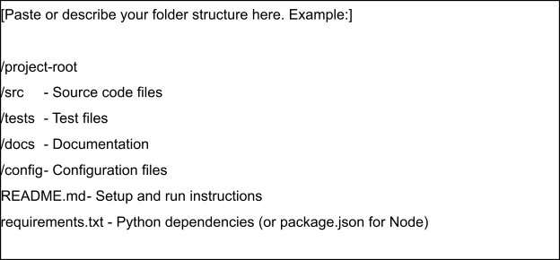
Step 3: Deployment / Access Details
Field | Details
Hosted / Deployed URL
Login​ Credentials  (Demo) | [Provide demo username and password for evaluator access]
Platform​ /​ Hosting  Provider | [e.g., Render, Vercel, AWS, Heroku, Azure]
Repository Link
Demo Video Link

 | 
Step 4: Run Instructions
Provide clear, step-by-step instructions for the evaluator to run your project locally:
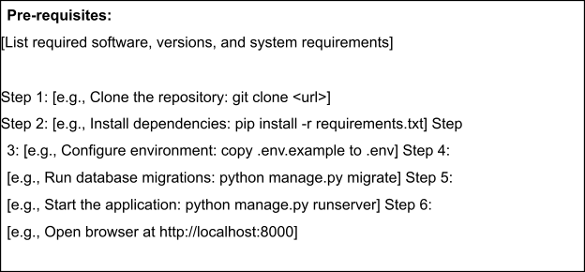
Step 5: Known Issues / Limitations
S.No | Known Issue / Limitation | Workaround / Status
1
2
3

